Gabe captures and comments in green

Brooke comments in blue

(We should perhaps invite Brooke to contribute too?)

1/22/14

* Hopes & Dreams
  + Noticed that we talked to much, should have had the students do more of the unpacking
* Intro Lecture
  + should be more interactive, should ask more questions
  + Consider starting with the brick example running it the way you did (they really perked up to this). That worked great. You may want to add a photo of a clear non system (bricks randomly scattered?)
  + I liked the healthcare.gov, but you were likely too thorough and lost them at several points. Consider highlighting a smaller number of salient points. Love the tweets (but remember that it was hard to see the tweets because of small screen projection size). Keep the iceberg and pyramid too.
  + Introducing Objects, Relationships, Currency, Boundary makes sense, but consider maybe using photos in addition (or instead?) of your diagrams. I say this because note how only one person in the class one week later had any memory of what you had presented on currency.
* Break
* Physical Activity
  + Class split into two groups
  + One group goes outside while group given ‘the rules’
  + Group practices behavior then outside group brought in and watches behavior trying to guess the rules
  + Two different rules
    - pick someone and try to stay always behind them
    - pick two people, designate one as your bodyguard the other as your assassin and always try to keep the bodyguard between you and the assassin
* Go over syllabus (highlights on slides)
* Teacher introductions (When 2 teachers in one class, let’s make these shorter. I (Gabe) need to show less work)

1/27/14

* Drawing exercise
  + set up still life
  + draw it 4 times
    - 8 minutes any way you want
    - 3 minutes draw only outline
    - 3 minutes draw only negative spaces
    - 8 minutes any way you want
  + didn’t totally work in terms of the later drawing being different or clearly more observed than first
  + Thought this was a great way to start the class and get them engaged especially since the lecture was a bit longer than usual
* Visualizing Systems Lecture
* >break<
* Discussed Arcadia
* Studio to begin writing

1/29/12

* Student intros 25mns
* 30-40mnsCurrency Experience This generated some good discussions and I was also pleasantly surprised that students all started diagramming. Closer to 60mns is needed. A few students did not participate in the discussion at all though… we should keep an eye out for these and engage them more.
* 30mns diagramming lecture (IMHO way too many points were made in way too few slides. Consider making 3-5 points in 3-5 slides (one sentence and/or illustration per point) and really driving each home. It might be interesting to put aside time to first hear whether students have experience creating diagrams and lessons they’ve learned)
  + I agree it would be interested to see a show of hands re: which students have experience with diagrams
* >break<
* 30mns activity (warped juggle or avalanche) --we ran out of time for this
* 15mns diagramming assignment
* 45mns studio times (diagramming lesson-relationships)

2/3/14

* critique of Relationships lesson (~50min including posting/milling around)
  + ran this as 4 separate critiques where students in groups of 4-5 critiqued each other, 5 minutes/person
  + i circulated tried to swoop in and disseminate wisdom
  + after group sessions complete I had each group choose one person to present their work to the whole class
  + then we did a final general wrap up discussion
  + this process worked pretty well
* Discussed Meadows 1,2 (~70min--lots of engagement up to 60 min)
  + very lively discussion
  + themes we covered well
    - how rules of system define the system more than the specific elements in it--can change players on a football team it is still a football team
    - lots of connection with sufi story that to understand 1 and 1 you need to understand ‘and’
    - how stocks/flows is a dynamic view of system--can analyze this way without having any idea how the system actually works
    - feedback, what it is, types
    - latency, what it is, how it relates to feedback
    - idea that with stocks/flows any ‘improvement’ you make (e.g. more stock) comes at a cost (e.g. slower response to change)
* Break
* Introduced Terminology Lesson, then studio
  + in verbal intro explained the lesson
  + came clean that I have struggled to find a good way to communicate how much words matter
  + framed it that this assignment was about teaching the idea that every system has its own private language, true at every level from baking to nuclear reactor

2/5/14

* Discussing Meadows 45mns: Thought this went well, started very structured, then became more freeform, but the students were engaged and involved in getting clarification on concepts
* Physical activity (hoops) 30mn: This worked and lead to a good discussion. One thing I’d do differently: no demo, just breakup people into groups and have them try it (otherwise people strategize before they do it and effect of hoop going up is less surprising). Big point made: system can defeat peoples best intentions. also, a good number of strategies can overcome the problem of hoop rising. Terminology
* Terminology discussion: surprised by how excited students were by their terminology findings and thought this was a nice discussion
* 20mns
* Break
* Introduce the Term Project 20mns: I was a little disorganized in my presentation in part because I was struggling with how much detail to give of the long term view at this stage. Many questions came up, students wanted to know the end game of this
* Discuss ideas for Term Theme 55mns (20mns brainstorm, last 30mns individuals present)

2/10/14

* Beer Game
  + this was somewhat disasterified!
  + took ~45 minutes to get tables set up, and then didn’t do it quite right
  + next year remember that all 4 teams (per supply chain) have exactly the same table set up
  + only differences are that factory gets two production sheets instead of delays, and retailer does not need delay sheets
  + next year, have TA set up tables while I explain and train the teams
  + didn’t do a training run, thought it would be easier to just get going but this was wrong, took ~15 cycles before people really started getting it
  + need to walk people through the spreadsheet, also need to modify it so it is clearer that each round you enter 3 pieces of data, two of which are given to you, and only one is your (team) decision
  + gave bad rule that teams had to wait to receive an order before placing one--think that should be up to them
  + need to run the thing more robotically, with every team doing the same action at the same time the step by step thing is clearer
  + Interestingly, even though didn’t go as plan, debrief went OK, people still saw some of the lessons, realized that their order strategy was flawed, and that stress was almost inevitable
  + Even though this felt somewhat disastrous, I felt like it actually got across the concept fairly well (systems can fail / delays, etc)
    - I think there was a ton of value in recapping how people felt during the game, what they think failed, how they would improve
* Break
* Introduce Feedback lesson
  + kept this very short, mainly just reiterating terminology and showing examples of what I expect for the lesson submission

2/12/14

* Student term projects link: <https://docs.google.com/a/cca.edu/document/d/1-dmaPjM7Z7qJqKN9IuE-vsLlBxnnW31JdcjzO59tG9M/edit>
* Uploaded additional images to Edmodo from today’s activity
* A number of students did not bring printed diagrams for pin up critique. I said wasn’t OK to shown on laptop instead. Documented which students brought print out and intended to dock 1 participation point from those that didn’t but now have found that I lost the notes about who did and didn’t bring the print out. Perhaps just as well as I ended up feeling conflicted about this, wondering if print out requirement was sort of archaic?

2/17/14

* Discussed Meadows Ch 6, Leverage points
  + Went briefly through each point
  + Discussed why arranged in the order given
  + grouped items into 3 groups of four, to do with structure, to do with control, to do with purpose
  + This process felt pretty good, lots of engagement
* Discussed Meadows Ch5 and Anderson/Johnson excerpt
  + had a bit of flail trying to discuss the issue of archetypes in general
  + didn’t attempt to go through each one specfically
  + brought with me front page of Chronicle, took two example stories from it and went through mapping them to archetype
  + pointed out that Meadows includes two archetypes that are not in Anderson/Johnson
  + Need to add diagrams for these to handout for next year:
    - Rule Beating
    - 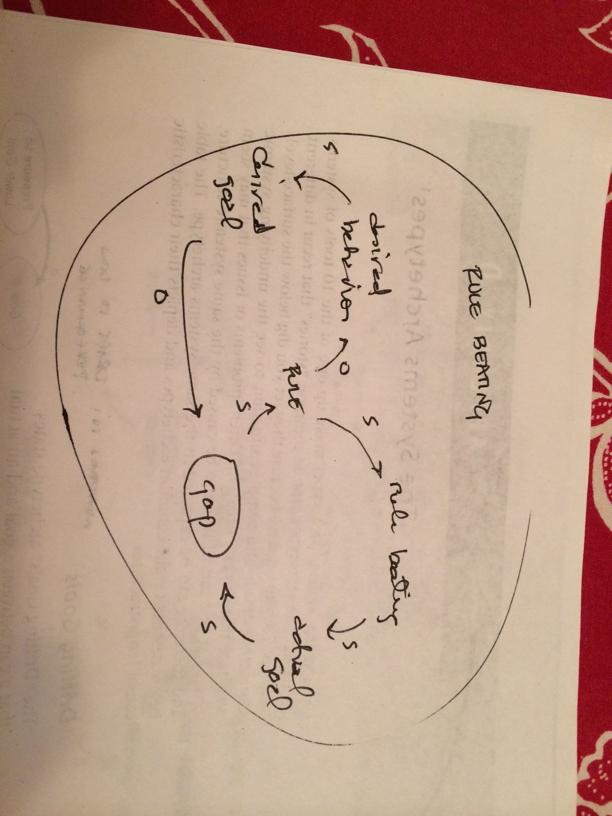
    - Seeking Wrong Goal

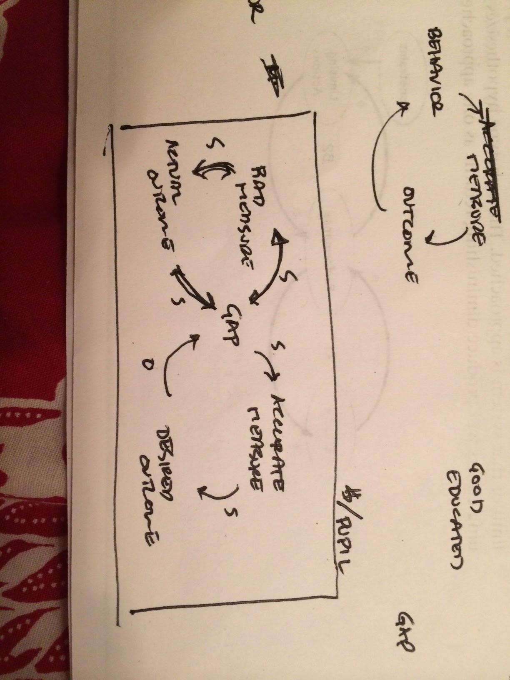

* Break
* Studio where they worked on their archetype assignment

2/19/12

* short small group critique of archetype lesson
* discuss reading (lead by Hugh)
* > break <
* wolves/sheep exercise (lead by Hugh)
* discussion of BART mental models map (lead by Hugh)

2/24/12

* take questions about term project
  + questions about how to plan interviews; answered by talking about wolves/sheep video shown by Hugh as a guide for the kind of information the research phase needs to yield
* lecture: how the internet works
* hands on: posting file to your web server account via ftp
  + not all students had tried before class and some did not have accounts--need to emphasize next year that they may need to contact helpdesk before hand to get account set up
  + Will showed us that Mac Finder has built in FTP client (Go>Connect to Server) and this is much easier than using Cyberduck, however, requires additional explaining about the distinction between working locally and remotely
* >break<
* introduce html programming; demonstrate how to get started with lesson 6
  + went smoothly, worked through creating files, creating header, navigation, section tags, creating navigation links as a list
* studio: work on lesson6

3/3/14

* Seems like it might be a good idea to send out a file with the JS you will be using or accessing during the class. Many students had a hard time keeping up with typing it in since it’s a language they are unfamiliar with